- Click Search. If I only want articles I can read online I’ll tick the Full text articles box .

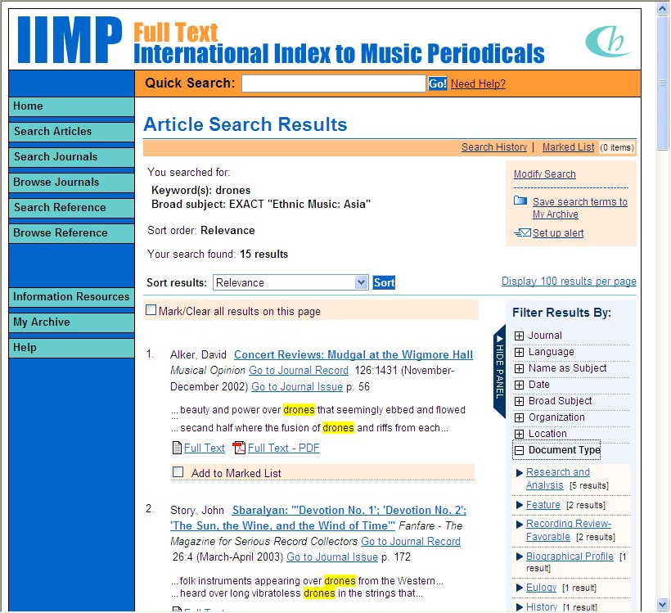

- I found 15 items. This isn’t enough so I’ll do another keyword search by drones India, and get 95 items.

- Some articles will have full text online.

Others I can possibly get at other libraries using my free CAVAL card (I got it at the Whitehorse loans counter). Or I can ask for an interlibrary loan, which may take 3 weeks.
I’ll check out TROVE to find which libraries to use (See the TROVE brochure).
My Notes

Databases @ Box Hill Institute | 

IIMP
International Index
to Music Periodicals FullText

IIMP is a specialist music resource.

It has full text articles from a wide range of music journals and magazines. Also an index to many more journals you may find at other libraries.

For more information please contact
Fran Morrissey or Susannah Ball
ext. 9799, Whitehorse Library
or email
F.Morrissey@bhtafe.edu.au,
S.Ball@bhtafe.edu.au
These instructions will get you started.

But when you’re familiar with International Index to Music Periodicals, you’ll find your favourite ways of searching.

- You can log into StudentWeb, then navigate to Library Databases. Scroll down to International Index to Music Periodicals and click. You may need to log into the Box Hill proxy server.

- Alternatively,
log in at http://ezproxy.bhtafe.edu.au/login?url=http://iimpft.chadwyck.com
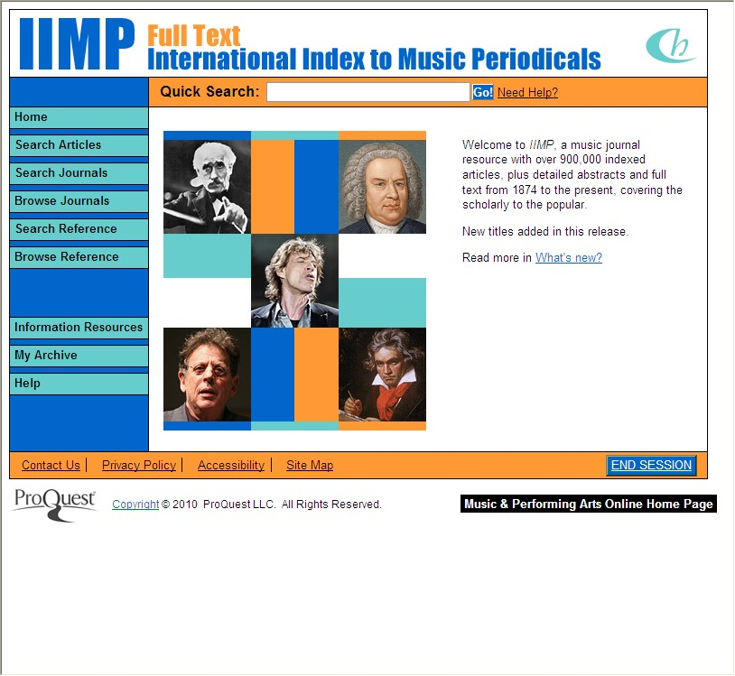
- The home page will allow a Quick Search (top) or Search Articles (in the lefthand column). I recommend Search Articles.

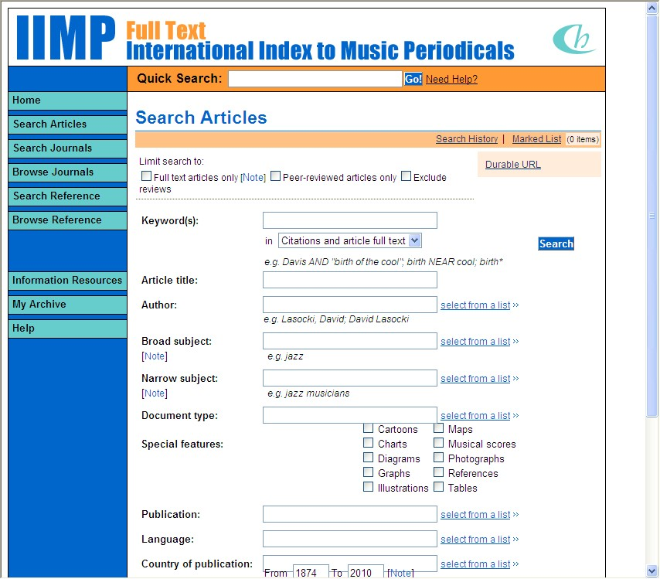
- Type in one or more keywords. I’ll search on drones. Next go to the Broad or Narrow subject box and click on Select from a list.

I’ll try Broad subject.
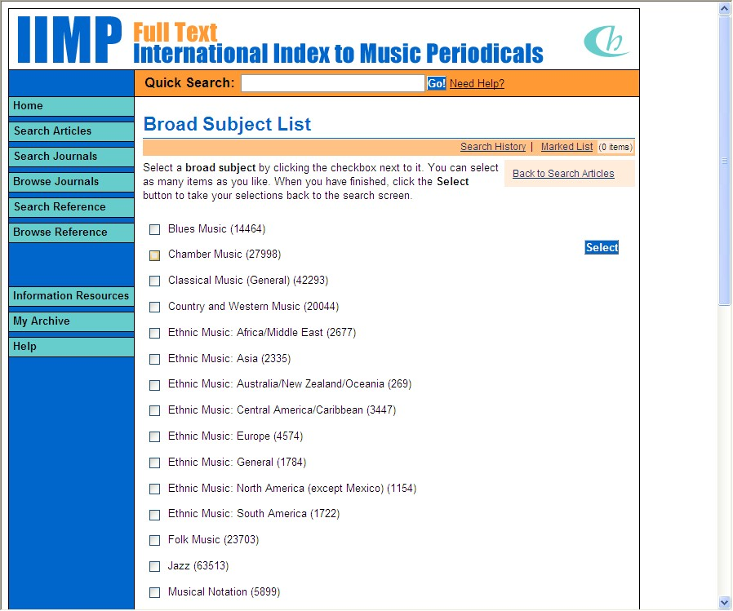
- I’ll select Ethnic music: Asia. (Or Theory/Analysis/Composition. Why not do two or more searches?)


