- TROVE is a pleasure to use. It really has a treasure trove of information. If you’re interested in family history try the old newspapers – just search by your ancestor’s name.

- What is CAVAL, you might ask? It stands for Cooperative Action by Victorian Academic Libraries. The library you’re enrolled at will give you a free card on request, with spaces for the barcodes of the other libraries you may go to.

The card will last up to 12 months. There are strict conditions. You cannot have fines owing at your home library. You must never return books late to the other libraries either, or your card will be cancelled.
My Notes

TROVE

Databases @ Box Hill Institute | 

TROVE is the National Library of Australia’s flagship resource. It has details of holdings in almost every Australian library.

You can consult it to find what libraries to go to, to borrow with your CAVAL card. (You can get a CAVAL card from any of the BHI campus libraries).

We also consult it before asking for interlibrary loans.

For more information please contact
Fran Morrissey or Susannah Ball
9286 9799, Whitehorse Library
or email
F.Morrissey@bhtafe.edu.au,
S.Ball@bhtafe.edu.au

- TROVE is at http://www.trove.nla.gov.au

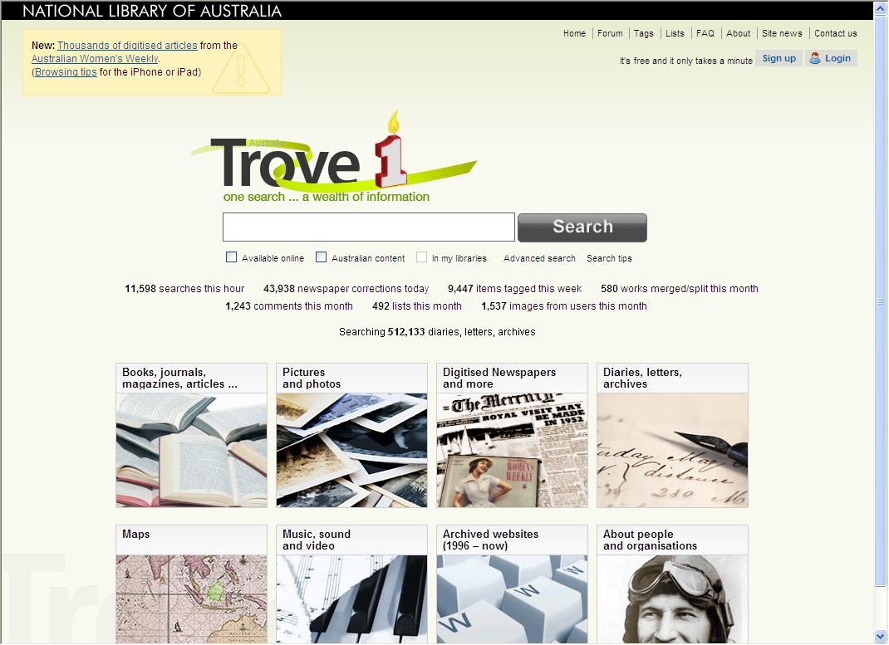
- If you’re looking for a particular book, key in the author’s surname and 2 or 3 words from the title. I’m looking for John Tavener’s memoir The Music of Silence, which BHI does not hold.

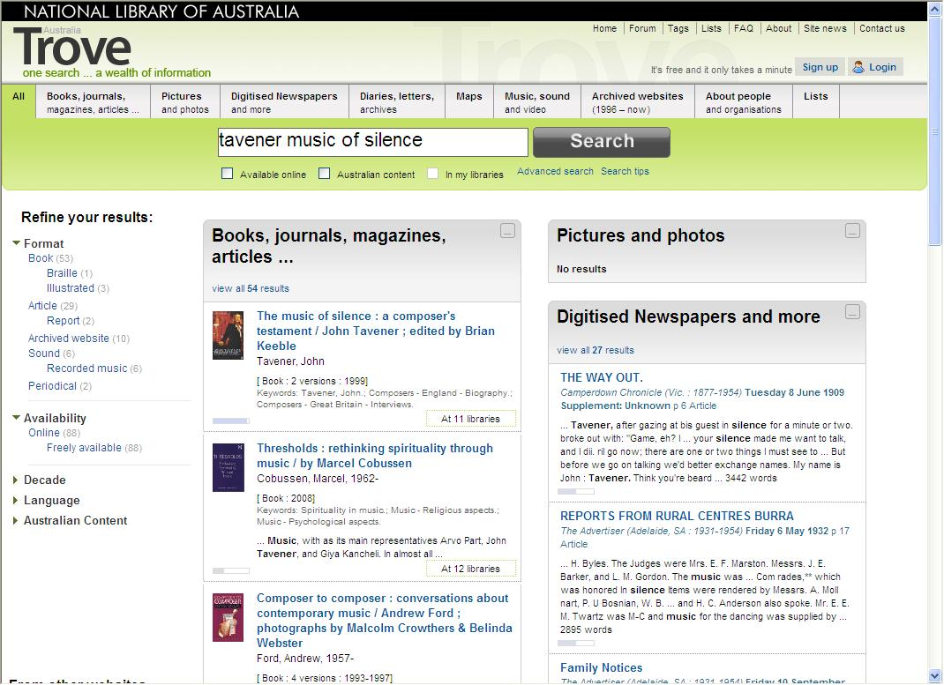

- TROVE shows me windows of different formats including Books and other print resources, Pictures and photos, Newspapers, etc. with 54 items total. The book I want is top of the list. It’s held at 11 libraries.

- I’ll click on the title of the book I want.

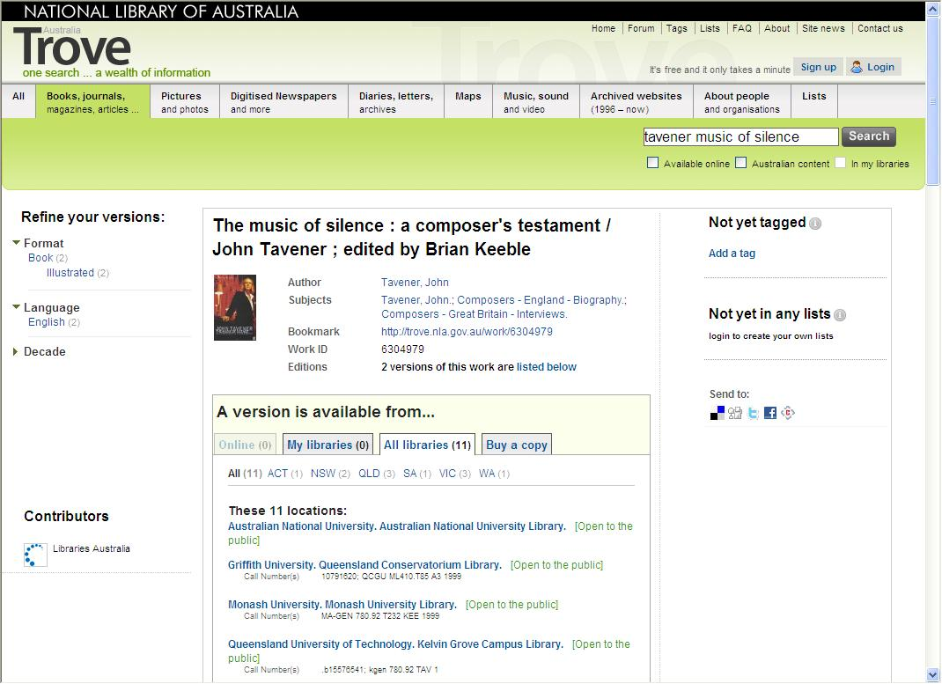

- TROVE shows me the versions and lists the libraries that hold them. I can view the libraries state by state, if there are a lot of them.

- The Victorian libraries are Monash University, State Library and University of Melbourne. I can borrow from the universities using my CAVAL card. So I’ll click on each library’s name to go through to its catalogue to see the branch, call number and availability.
- Searching for a journal name is easy, too. I’ll search on Journal of Film Music. It comes up top of the list, too.

- Sometimes a journal search can be swamped by a huge number of books with similar titles. If so, Look under Refine your search (the left-hand column) and choose Periodical or Journal, magazine, other.

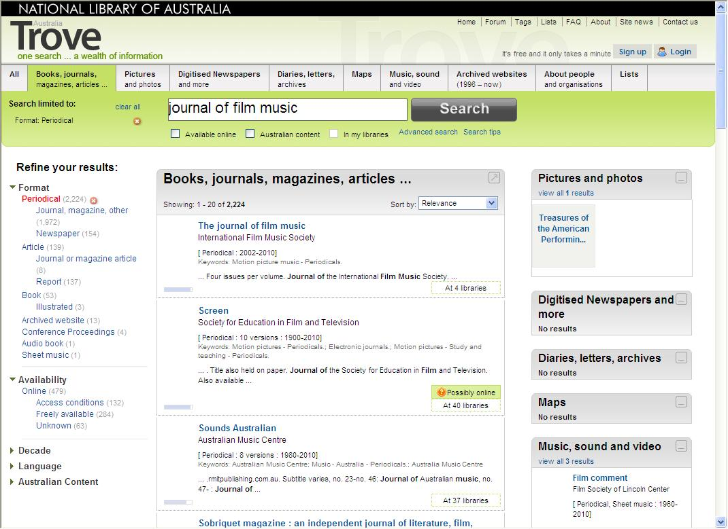

- I’ll click on the title. It immediately tells me the only Victorian location is Monash University Library.

- I won’t be able to borrow a journal through the CAVAL scheme, so I’ll ask for an interlibrary loan, which will give me a photocopy.

